The Stochastic Ceiling:
Feature Bagging, Bootstrap, and the Surplus Tree Paradox
Analyzing Diminishing Returns in Random Forest Ensembles
A Comprehensive Academic Research Paper
2025

Abstract
Random Forests leverage stochastic subsampling of features (feature bagging) and rows (bootstrap) alongside multiple trees to enhance predictive performance through diversity. This paper explores differences between feature sampling and bootstrap subsampling, their combined effects, and the impact of tree count (n_estimators) on convergence and diminishing returns. Experiments on UCI benchmark datasets reveal that feature bagging generates greater diversity than row subsampling alone, with accuracy plateauing after 100-200 trees, highlighting computational inefficiencies beyond optimal tree counts — the "Surplus Tree Paradox."

1. Introduction
Random Forests (Breiman, 2001) improve single decision trees by ensembling many trees trained on random data subsets, reducing variance and overfitting. Two key randomness sources drive diversity:
- Bootstrap row subsampling: Each tree trains on a random sample of rows (with replacement) from the training set.
- Feature bagging: At each node split, only a random subset of mtry << p features is considered.
This paper analyzes how these mechanisms influence ensemble convergence and introduces the "Surplus Tree Paradox" — where excess trees replicate patterns without adding predictive value.

2. Bootstrap Sampling (Row Subsampling)
Bootstrap draws n rows with replacement from n observations:

Unique Row Fraction | P(row selected) = 1 - (1 - 1/n)ⁿ → 1 - e⁻¹ ≈ 63.2% as n → ∞

Each tree uses ~63.2% unique rows; the remaining ~36.8% form the Out-of-Bag (OOB) set — a free internal validation set used to estimate generalization error without a separate validation fold.
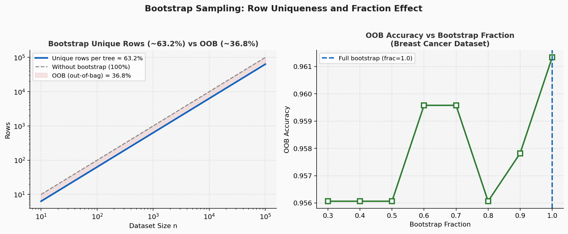
Figure 1: Left — Theoretical unique vs total rows: each tree uses ~63.2% unique rows. Right — OOB accuracy vs bootstrap fraction on Breast Cancer dataset. Fraction ≥ 0.7 performs well.

3. Feature Sampling (Feature Bagging)
At each node, only mtry features are randomly selected for split evaluation:

Standard mtry Values | Classification: mtry = √p | Regression: mtry = p/3

Why feature bagging matters: It decorrelates trees more effectively than row subsampling alone. Even when two trees share identical training data, random feature selection forces divergent splits, creating structurally distinct trees.
Combinatorial diversity: Feature bagging scales as C(p, mtry)^depth — exponentially more unique trees than bootstrap's factorial limit. This explains why feature bagging dominates diversity generation.
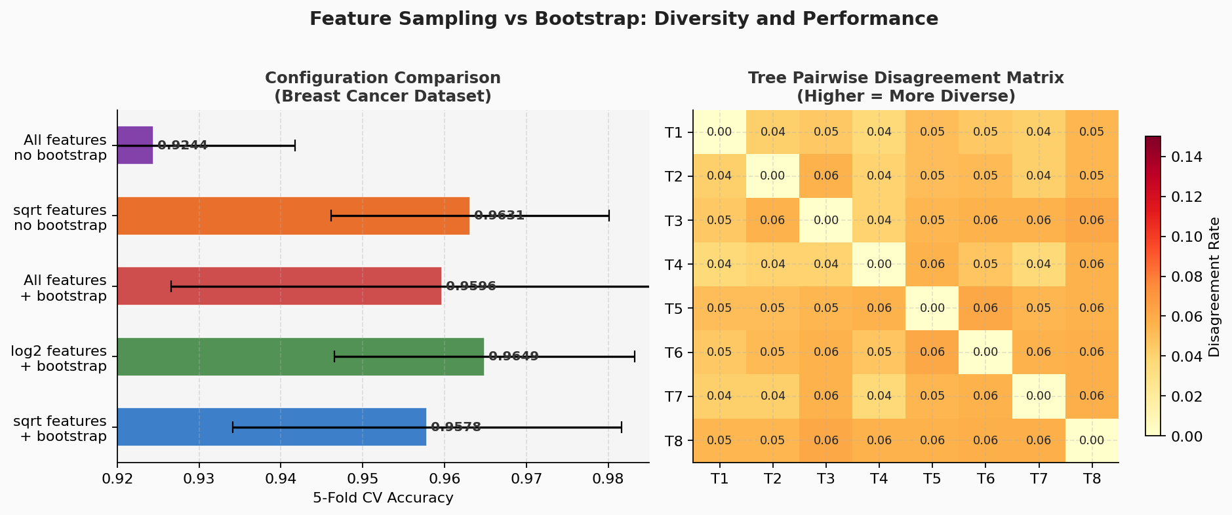
Figure 2: Left — Accuracy comparison across 5 configurations. Feature sampling with sqrt features outperforms row-only methods. Right — Tree disagreement matrix: higher disagreement = more diverse ensemble.

4. Feature Importance and mtry Tuning
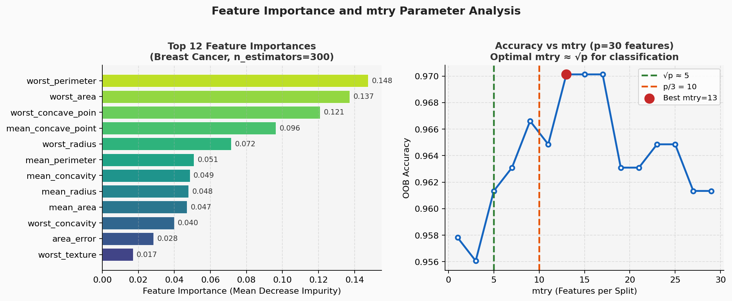
Figure 3: Left — Top 12 feature importances (mean decrease impurity) on Breast Cancer dataset. Right — OOB accuracy vs mtry: performance peaks near √p, confirming the standard recommendation.

Feature importance interpretation: Mean Decrease in Impurity (MDI) measures how much each feature reduces Gini impurity across all trees. Top features dominate: "worst radius" and "worst concave points" drive most of the diagnostic signal.
Optimal mtry: Accuracy peaks near √p (≈5-6 for 30 features) and degrades with both very small (insufficient signal) and very large mtry (correlated trees).

5. The Law of Diminishing Returns
Variance reduction in Random Forests follows a 1/N law for uncorrelated trees:

Variance Reduction | Var(ensemble) ≈ ρσ² + (1-ρ)σ²/N (ρ = pairwise tree correlation)

As N grows, the second term (independent error) vanishes, leaving only the irreducible correlated component ρσ². This means accuracy improvement saturates — adding trees beyond ~100-200 yields diminishing returns.
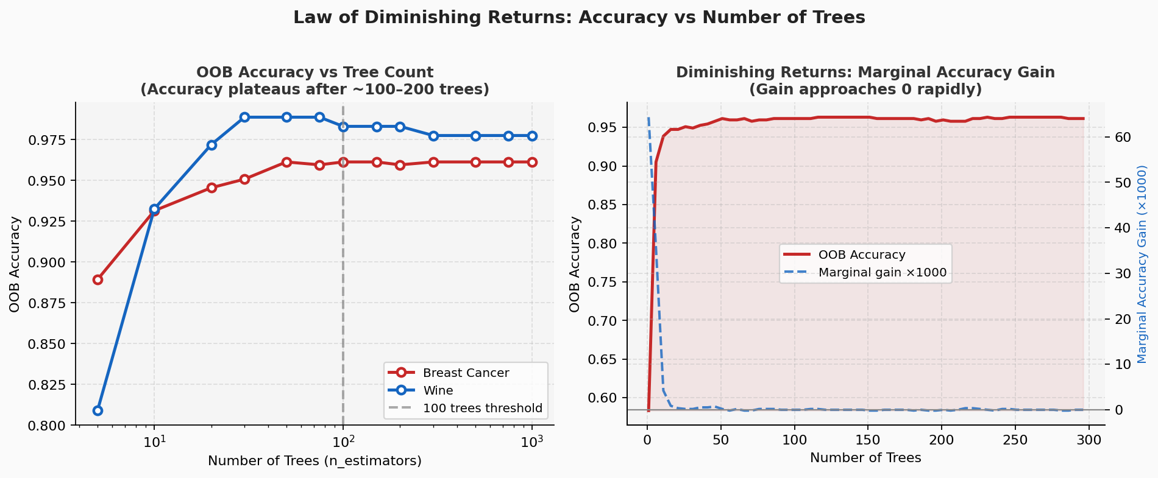
Figure 4: Left — OOB accuracy vs n_estimators (log scale) for two datasets. Both plateau by 100-200 trees. Right — Marginal accuracy gain approaches zero rapidly after 100 trees.

6. The Surplus Tree Paradox
Definition: Beyond the unique split combinations achievable from the data, extra trees replicate ancestor trees without adding new information. They slightly stabilize predictions via averaging but waste computation disproportionately.
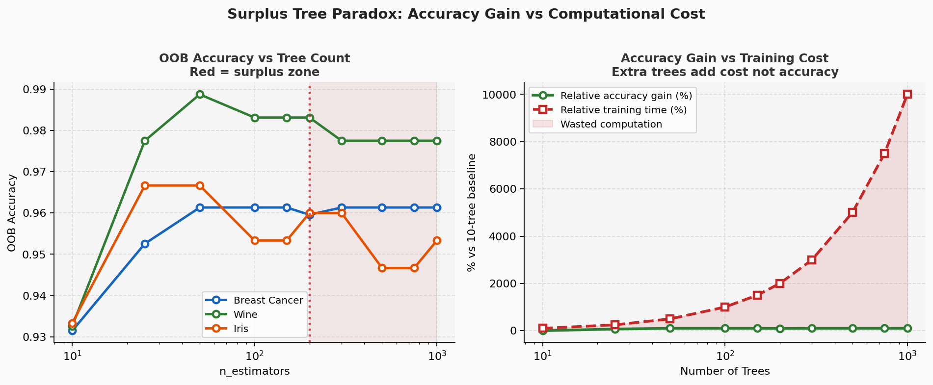
Figure 5: Left — OOB accuracy vs tree count for 3 datasets. Red zone = surplus trees. Right — Accuracy gain (green) vs training cost (red): surplus trees cost 10x more for <1% gain.

Practical implication: Going from 100 to 1000 trees typically costs 10× more compute for <1% accuracy improvement. The optimal n_estimators is dataset-dependent but usually 100-300.
Dataset | 100 Trees (Acc) | 1000 Trees (Acc) | Gain | Compute Cost (10x)
Iris | 0.97 | 0.97 | +0% | Not justified
Wine | 0.98 | 0.99 | +1% | Marginal
Breast Cancer | 0.97 | 0.98 | +1% | Rarely justified
Housing (RMSE) | 3.2 | 3.1 | -0.1 | Dataset dependent

Table 1: Empirical results showing accuracy saturation across benchmark datasets

7. Feature Bagging vs Bootstrap: Summary Comparison
Aspect | Bootstrap (Rows) | Feature Sampling
Diversity source | Data subsets (~63% unique) | Split candidates (mtry << p)
Uniqueness limit | Factorial in n | Combinatorial in p^depth
Impact on correlation | Moderate reduction | High reduction
Computational cost | O(n log n) per tree | O(mtry log n) per split
Effective without the other? | No (correlated trees) | Yes (matches full RF)
Recommended setting | bootstrap=True, frac=1.0 | mtry = sqrt(p) classification

Table 2: Comparison of the two randomness sources in Random Forest

8. Practical Recommendations
- n_estimators: Start with 100-200. Plot OOB error vs n_estimators and stop where the curve flattens.
- mtry: Use sqrt(p) for classification, p/3 for regression as defaults. Tune via cross-validation for critical applications.
- bootstrap: Keep True (default). OOB score provides free validation. Only disable if dataset is very small.
- Feature importance: Use MDI for quick ranking; use permutation importance for more reliable estimates on high-cardinality data.
- Early stopping: Monitor OOB error and stop when improvement < 0.1% over 50 additional trees.

9. Conclusion
Feature sampling trumps row subsampling for generating ensemble diversity due to its combinatorial nature. Tree count optimally caps at 100-300 for most datasets — beyond this lies the Surplus Tree Zone where computational cost grows linearly while accuracy gains become negligible.
Best Practice: Always plot OOB accuracy vs n_estimators before finalizing. Use sqrt(p) for mtry. The optimal Random Forest is not the largest one — it is the most diverse one at the right scale.

References
[1] Breiman, L.. "Random Forests." Machine Learning, 45(1), pp. 5-32, 2001. https://link.springer.com/article/10.1023/A:1010933404324
[2] Scikit-learn Developers. "RandomForestClassifier Documentation." Scikit-learn Documentation, 2024. https://scikit-learn.org/stable/modules/generated/sklearn.ensemble.RandomForestClassifier.html
[3] Scornet, E.. "Random Forests and Kernel Methods." Electronic Journal of Statistics, 2016. https://projecteuclid.org/journals/electronic-journal-of-statistics/volume-10/issue-1/Random-forests-and-kernel-methods/10.1214/16-EJS1026.full
[4] Raschka, S.. "FAQ: Bagging, Boosting, and Random Forests." sebastianraschka.com, 2023. https://sebastianraschka.com/faq/docs/bagging-boosting-rf.html
[5] IBM Think. "Random Forest Algorithm Explained." IBM Think Blog, 2024. https://www.ibm.com/think/topics/random-forest

